Lesson 1 Homework Practice

Scatter Plots

Interpret each scatter plot.

1. 2. 3.
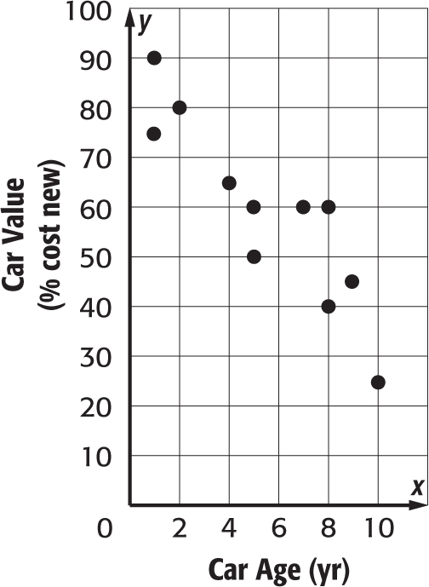
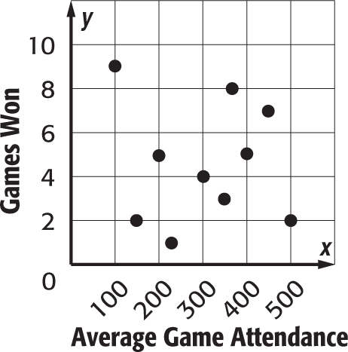
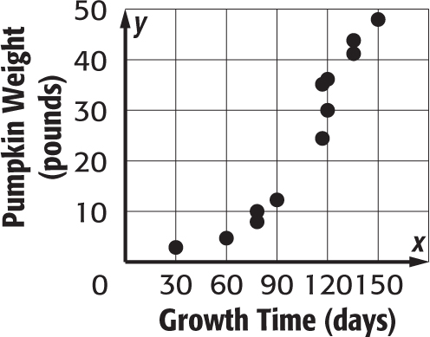

4. RIVER Construct a scatter plot of the river’s width and the water’s speed.
River Width (m) | 15 | 18 | 20 | 28 | 30 | 32 | 38 | 40 | 42 | 45
Water Speed (km/h) | 12.6 | 10.7 | 11.2 | 9.7 | 8.1 | 8.7 | 6.9 | 5.4 | 3.9 | 4.1

5. DONATIONS Construct a scatter plot of the number of cars donated to a local charity over the past five years since 2007.
Years Since 2007 | 1 | 2 | 3 | 4 | 5
Number of Cars | 14 | 21 | 30 | 28 | 35

